Application form for Leave of Absence (LOA) during Term Time
A. Pupil Details
Name: |  | DoB:
Address:
Class:

B. Leave of Absence Request Details
Start date of requested leave: |  |  |  | End date:
Return to school date: |  |  |  | No. of days:
What are the exceptional circumstances for your leave of absence request that you wish the school to consider?

Name of parent / carer (print):
Signature: |  |  |  |  | Date:
Name of parent / carer (print):
Signature: |  |  |  |  | Date:

Please email this form (fully completed) to office@laceygreen.cheshire.sch.uk or hand in to the office.

The National Framework for Penalty Notices Explained

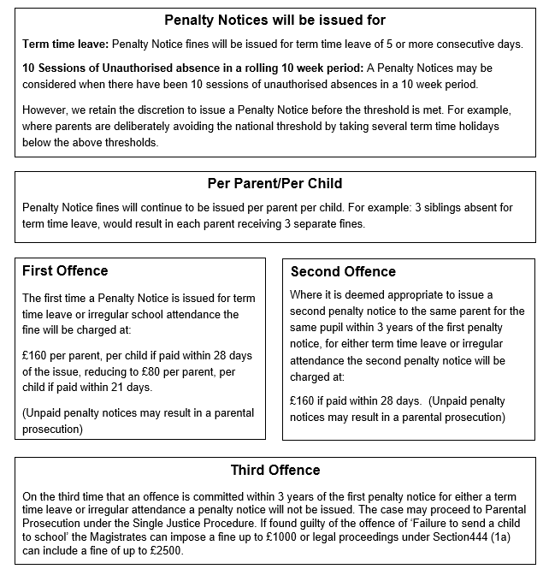

C. For Office Use
Current attendance %:
Previous LOA (last 2 consecutive half terms):
Does the LOA request time coincide with SATS / other examination periods?:
Any mitigating / aggravating circumstances (Including any ongoing medical issues):
Is the Leave of Absence (LOA) approved? |  | YES |  | NO
If YES - Number of days to be authorised for this LOA application:
Signature of Principal: |  |  | Date:
Register Code to be used for this LOA:
Date | Copy returned to parent/s with letter.
Copy filed and sent to class teacher – please sign

