Lacey Green’s EYFS team

R1 | R2
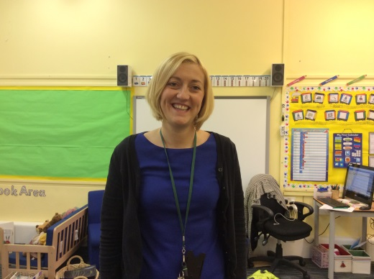  Miss Hall – class teacher and EYFS leader  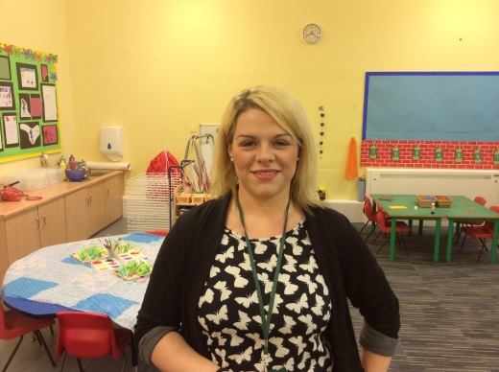  Miss Barnett – class teaching assistant | 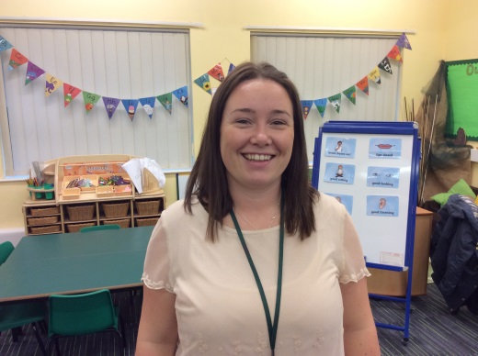  Miss Rowark – class teacher  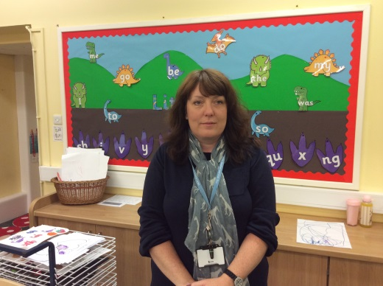  Mrs Roberts – class teaching assistant  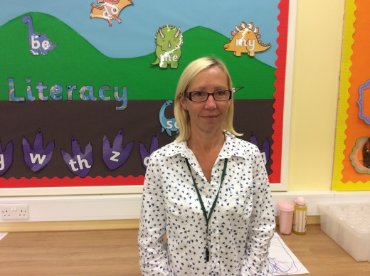  Mrs Shepherd – 1 to 1 support
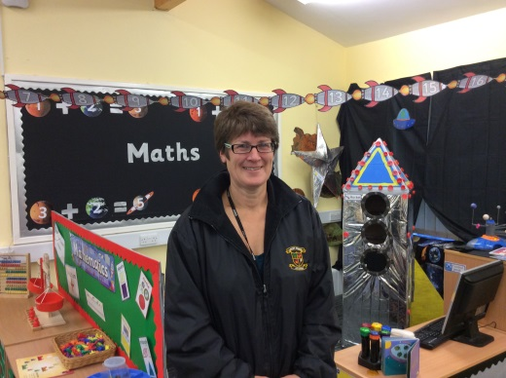
Mrs Oliver – PPA cover

